APP TO DO IT INCORPORATED

founded on the desire to create, reconnect and sustain healthy relationships
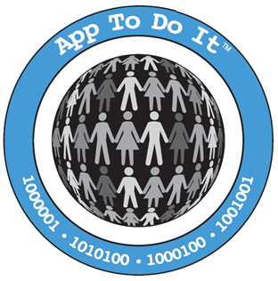
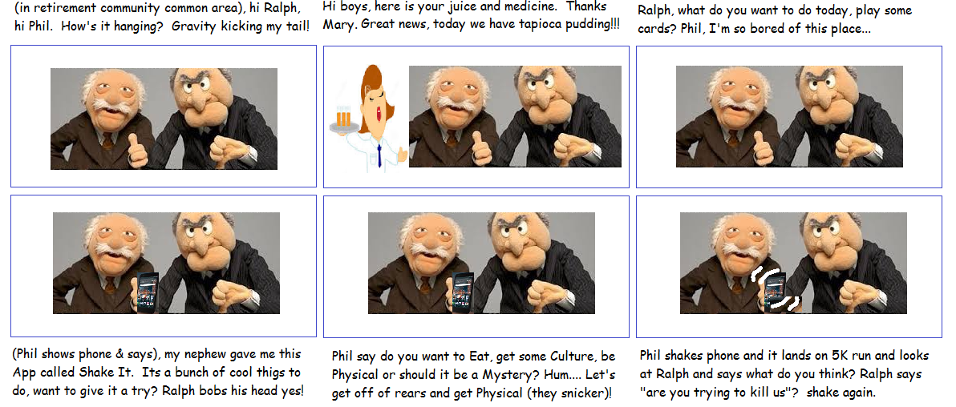

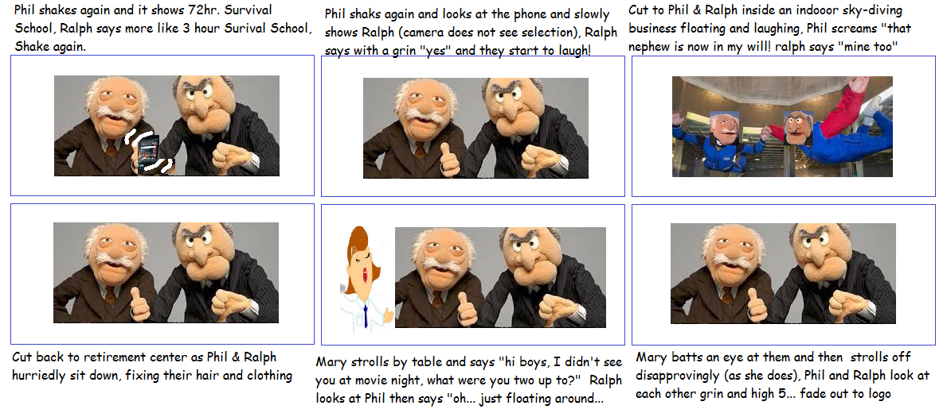

Lastly, I think I would like to suggest we create a corporate video first (with soundtrack) - looping. This will give us the opportunity to figure out how to use the camera, staff, actors, lighting, sound, editing etc. etc. Once this video is done, it will replace the spinning globe section of our homepage. I got this idea from this site. http://kakhulu.com/
What I see is maybe something like this (no words, just a quirky music story):
The theme is what I posted in the upper right hand of our website: “If you can dream it… You’re App To Do It…”
I see something like a kid, getting out of bed on a sunny morning quickly getting out of the house and interacting with his friends. BUT one friend feels left out because of what they are doing – like maybe swimming or skateboarding because that kid can’t swim or is uncoordinated. Then cut to your kid writing a note reading “never leave anyone out”, then he tears it off the pad and throws it into a special little box (cigar box)…
Then show him again as a high school kid in a crowd of cool people chatting about going somewhere (now that the basketball game is over). As they are going off as a crowed, your kid stands there and asks to bring Mike and Mary (as he doesn’t want to leave them). But a couple of A-male and A-females shake their head and wave “no, not them they don’t fit and don’t want to come” and pull your kid by the sleeve and drag him off with them as he is looking back at his friends (who look sad). Then cut to your kid writing a note reading “how can I include everyone in the fun”, then he tears it off the pad and throws it into that special little box (cigar box)…
Then cut to a college kid working on an App (computer screen with code, books on coding – the cigar box is also there) its late, his 2 friends are in the dorm room dancing with 2 girls parting and the kid is in the foreground creating this App. Cut to him in a suit in a conference room pointing to his App diagram and talking on a power point slide broadcast on a screen (which the diagram implies how to connect all people in fun, not leave anyone out) as he is presenting to a group of business people (5 or so), then cut to the business people’s face as they are approvingly shaking their head up and down, then show one of the business people writing a check and handing it to the college kid and shake hands.
Finally cut to a magazine cover (titled App Giants) with the college kids face on it smiling with a cigar and the headline reads “#1 App in the world says “if you can dream it… You’re App to Do It…”, then fade out and show the kid in a super car as he gives the magazine to a

beautiful woman in the passenger side, as she gazes at him and he takes off down the road in the super car (at the end, the video reads App To Do It if you can dream it… you’re App To Do It…

